Newsletter
Issue 8

3 November 2023

Dear Parents and Carers

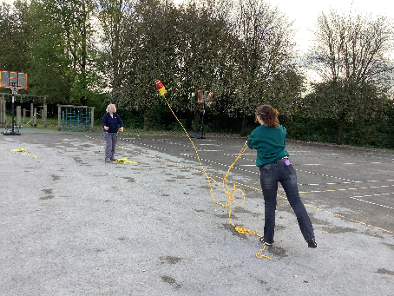
Inset Day
The staff had a very busy, but enjoyable day, doing their Outdoor Leaders training. They followed a map around the area and did throw rope training.

Hampshire Healthy Heroes
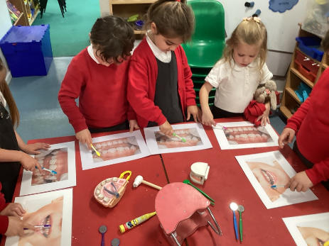
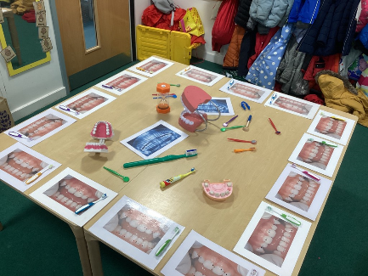
On Monday Squirrels class had a special visitor. Julie Ridge from Hampshire Healthy Heroes came to talk to us about keeping our teeth clean and healthy. She told us stories and taught us songs and then we were able to have a practice cleaning some pictures of teeth that had lots of marks on them. Squirrels learnt that we should brush our teeth twice a day in the morning and before bed. That we should only drink water after brushing our teeth at bedtime and that we should brush our teeth for two minutes.

Change of Menu
There will be a change of menu for the Jacket Potato option for Monday and Tuesday next week. Monday’s choice will be Cheese and Tuesday’s will be Tuna.

Nursery School
We will have spaces available in our Nursery for 2 and 3 year olds from January. If you are interested in a place or know somebody who may be interested please contact the school office for an information and enquiry pack.

Rocksteady Concert
The Rocksteady end of term concert will be on Monday 11 December at 2.30pm. Those who attend Rocksteady classes will also receive notification directly from Rocksteady.
School Council
Our school council met today and our meeting went very well. We talked about the important nd responsible role of being on the school council and being a school counsellor and all the children showed maturity and enthusiasm.

The children were able to talk about their ideas and thoughts around various issues and will be speaking to their classes and reporting back at the next meeting.

Thank you to all of the school counsellors for their contributions today and I look forward to our next meeting.

Mrs Davies

Photographer Visit
Please note that our School Photographers have had to change the date of their forthcoming visit. They will now be here on Tuesday 14 November. This is for individual and sibling photos.

If you have a child in Nursery who does not attend Nursery on Tuesday but you would like their photo to be taken please bring them to school for 9am.

Christmas Dates
Some dates for your diary –

Thursday 7 December - Christmas Lunch
Monday 11 December - Rock Steady Concert – 2.30pm
Tuesday 12 December – 2pm Nursery and Year R Nativity
Wednesday 13 December - Christmas Carols – 3.00pm (KS1 and KS2)
Thursday 14 December - Whole school trip to Pantomime (not Nursery)
Friday 15 December - No Breakfast Club

More details to follow for each event.

Learning Behaviours
We have held this week’s Learning Behaviours assembly. This is where each teacher chooses a child/children that has demonstrated the chosen learning behaviour of the week. The teacher shares with everyone what the child has done and then we all celebrate their achievement. This term we are looking at respect. The children who were chosen this week were:

Year One Amit D

Year Two Ada B-F

Year Three Henry T

Year Four Eloise M and Blake P

Year Five Christopher D and Yusuf P

Year Six Harper B and Emma P

School Lunches
Thank you to everyone for settling their lunch accounts, however the lunch debts are still high - please could you ensure that your account is kept up to date. For your information the money owed per class is as follows:-

Hares £ 219.73
Foxes £ 70.25
Herons £ 265.30
Kingfishers £ 207.50
Nursery £ 81.00

From Monday 18 September your child will not be able to order a school lunch if the debt is above £10.00 – if the debt is over £10.00 they will need to bring in a packed lunch. Please can you arrange to clear your Lunch accounts as soon as possible.

If you would like an up to date statement of your child’s account please contact the Admin Team. If you have not yet registered to pay online via Scopay and would like a copy of your login details please email us and we will be happy to help. We would appreciate it if all accounts, including any outstanding Breakfast Club and After School Club accounts, could be settled as soon as possible. Please ensure that your After School Club Account is up to date as we employ extra staff for this club. If you would like an up to date statement please contact the school office.

Thank you for your continued support.

Yours faithfully

Mrs Bordoli
Interim Headteacher

Dates for your diary (new dates in red)

School Photographer 14 November 2023
Open Morning (9.30am) 29 November 2023
Flu Vaccinations 5 December 2023
Christmas Lunch 7 December 2023
Rocksteady Concert 11 December 2023
Nursery and Year R Nativity – 2pm 12 December 2023
Christmas Carols 13 December 2023
Whole School Trip to Cinderella 14 December 2023
No Breakfast Club 15 December 2023
School breaks up for Christmas 15 December 2023
School returns for Spring term 2 January 2024
Open Morning (9.30am) 5 January 2024
Year R school applications close 15 January 2024
Inset Day 19 February 2024
Inset Day 28 June 2024
Inset Day 1 July 2024

